**Friday 27th September 2024**

**Maths**

Login to MyMaths and complete the set activities.

**P.E**

This week, try and challenge yourself to see how quickly you can change into your school uniform, your P.E kit and your pyjamas. Can you set yourself a timer and see if you can get quicker each day. Try and remember the strategies used in class about the process of changing and folding your clothes. We will be checking who can dress and undress in the quickest time. Good luck.

|  |  |  |  |  |  |  |  |
| --- | --- | --- | --- | --- | --- | --- | --- |
|  | **Friday** | **Saturday** | **Sunday** | **Monday** | **Tuesday** | **Wednesday** | **Thursday** |
| Time |  |  |  |  |  |  |  |
| Time |  |  |  |  |  |  |  |
| Time |  |  |  |  |  |  |  |

**Spellings**

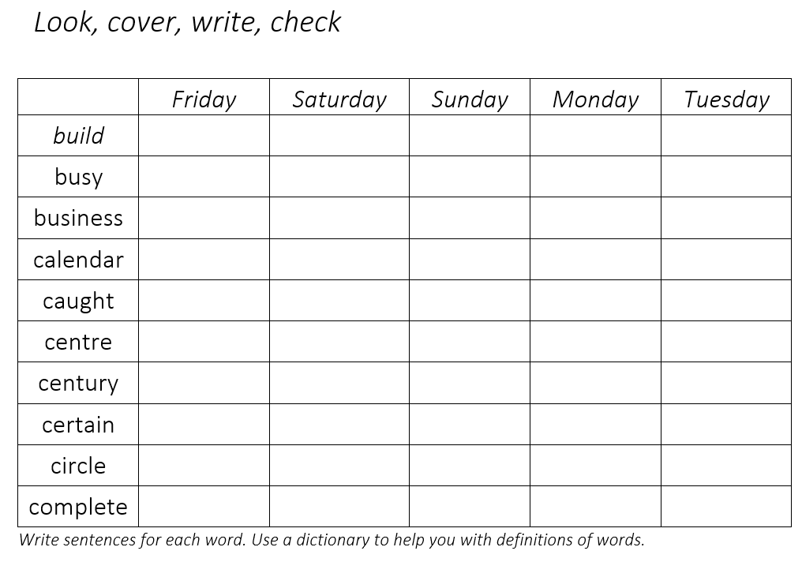

**Friday 27th September 2024**

**Maths**

Login to MyMaths and complete the set activities.

**P.E**

This week, try and challenge yourself to see how quickly you can change into your school uniform, your P.E kit and your pyjamas. Can you set yourself a timer and see if you can get quicker each day. Try and remember the strategies used in class about the process of changing and folding your clothes. We will be checking who can dress and undress in the quickest time. Good luck.

|  |  |  |  |  |  |  |  |
| --- | --- | --- | --- | --- | --- | --- | --- |
|  | **Friday** | **Saturday** | **Sunday** | **Monday** | **Tuesday** | **Wednesday** | **Thursday** |
| Time |  |  |  |  |  |  |  |
| Time |  |  |  |  |  |  |  |
| Time |  |  |  |  |  |  |  |

**Spellings**

