**Friday 20th September 2024**

**Maths**

Login to MyMaths and complete the set activities.

**English**

This week, you have been looking at similes and metaphors. Can you create your own, based on your favourite film, book or comic book character?

*For example:* Miss Fitzpatrick is as kind as an Angel.

Can you think of **at least** 5?

**Spellings**

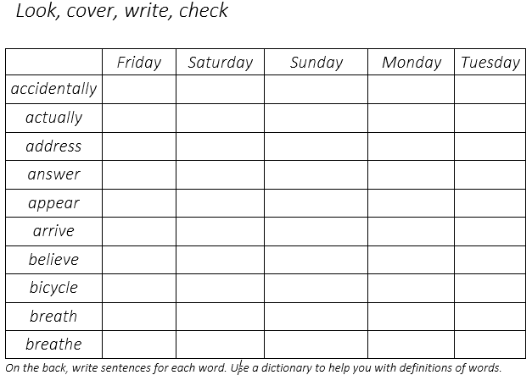

**Friday 20th September 2024**

**Maths**

Login to MyMaths and complete the set activities.

**English**

This week, you have been looking at similes and metaphors. Can you create your own, based on your favourite film, book or comic book character?

*For example:* Miss Fitzpatrick is as kind as an Angel.

Can you think of **at least** 5?

**Spellings**

